Localization with EV3 robot

LOTI.05.010 Robotics

Spring semester 2015/16

Practice session 8
In this session you will learn how to use ROBOTC, MINDSTORMS sensors, EV3 motors movement, synchronisation and also to use open loop control to move the robot to the position (x,y) and check it's angle between x-axis.

Tools needed:
- ROBOTC 4.x or newer
- USB cable
- Tape measure
- LEGO robot
- Taxi drive field

Work description
Minimum goal of this practice session is to make a program that drives robot to destination coordinates x,y shortest way as a task in program and goes through taxi drive mat with coordinats only.
Algorithm:
- You insert the coordinates to the program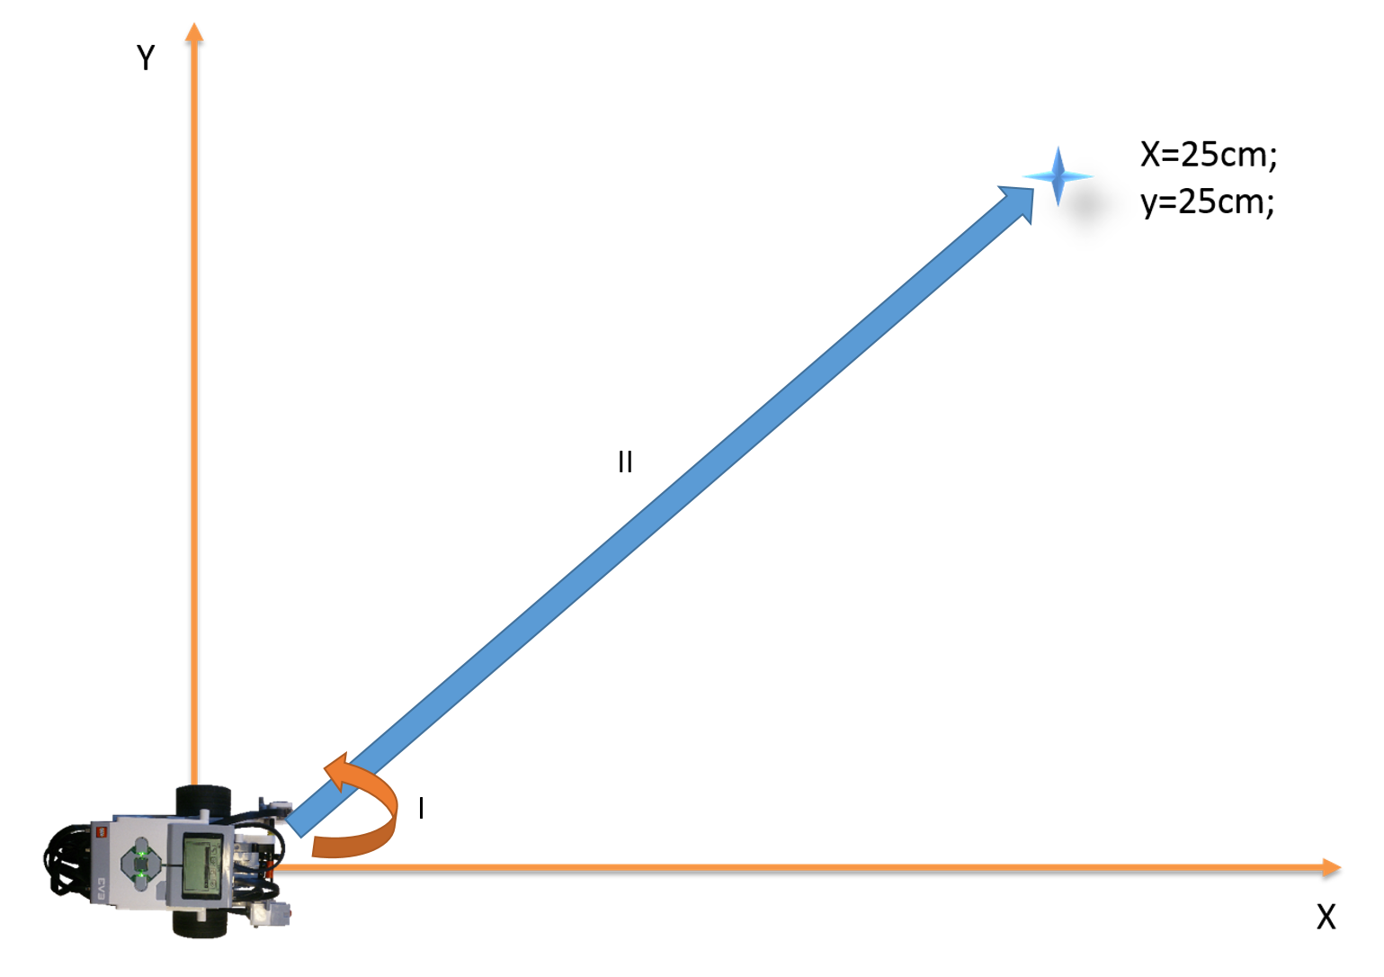
- Robot calculates angle it needs to turn and distance it needs to drive
- Robot turns towars the goal and drives right distance
- Robot turns to align x-axis
- BONUS(2 points): Robot measures error in turn by wheel encoders and corrects itself in each goal point.
- BONUS(10 points): Robot calculates its coordinates 10 times a second to understand it’s error and makes correction

Now, let’s implement the algorithm.

- Make a function that takes coordinates x, y and calculates angle Θ+ɑ
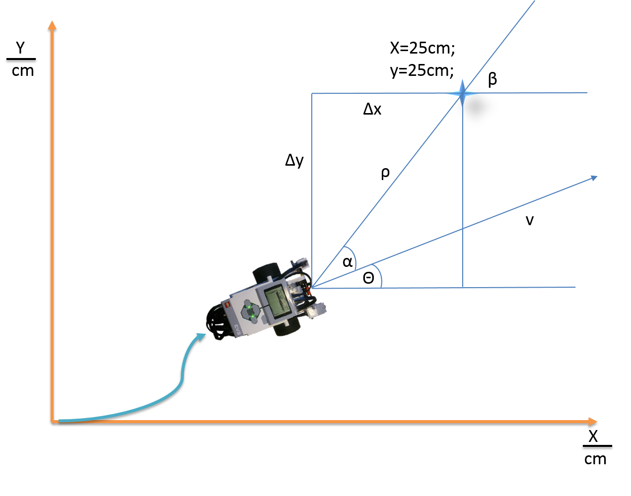
Figure 2. Robot localization
Function should look like this:
void task_name(type argument1, type argument2)
{
//your functions
//display your result to check if it’s true
}
task main()
{
task_name(5, 5);
}

1.2 Add to the same task a function that calculates the distance from the goal point ⍴ (Figure 2).
void task_name(type argument1, type argument2)
{
//your function that calculates angle
//your function that calculates distance to the goal point
//display your result to check if it’s true
}
task main()
{
task_name(5, 5); // x=5 and y = 5
}
2. Make the robot in the same task to (i) turn towards the goal point and (ii) drive to the goal point.
void task_name(type argument1, type argument2)
{
//your function that calculates angle
//your function that calculates distance to the goal point
//make the robot turn and drive to goal point
}
task main()
{
task_name(5, 5); // x=5 and y = 5
}

2.1 Now the robot is in goal point, but it is not aligned towards the x axis if the target was not on x axis. Add functionality that robot turns back the angle it was turning to the goal point.

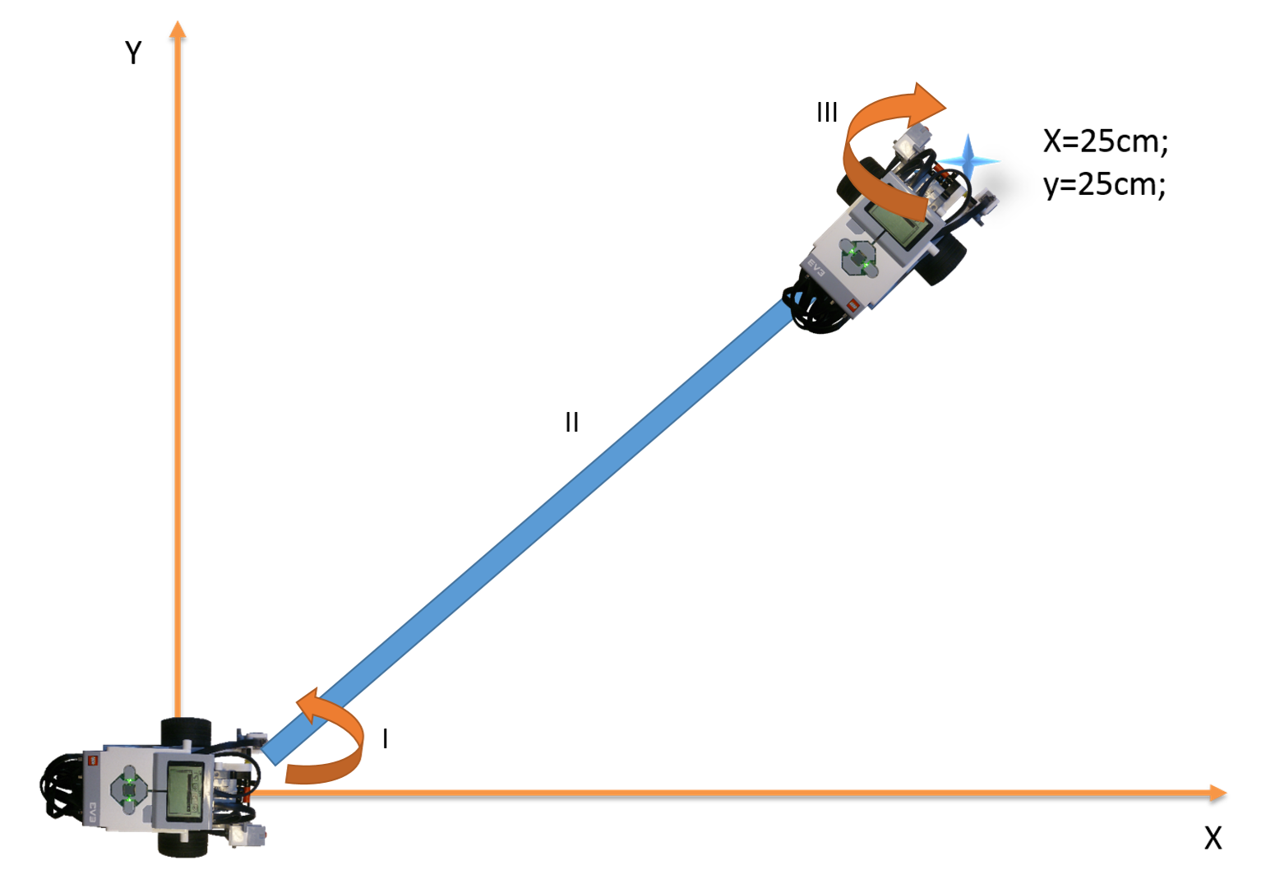
void task_name(type argument1, type argument2)
{
//your function that calculates angle
//your function that calculates distance to the goal point
//make the robot turn and drive to goal point
//make the robot turn back to align with x axis
}
task main()
{
task_name(5, 5); // x=5 and y = 5
}

3. Make the robot to drive through the city with coordinates like this:
task main()
{
task_name(70, 0); // x=70 cm and y = 0 cm
task_name(0, 80); // x=0 cm and y = 80 cm
….
}
Coordinates are yours to measure.
Show your code and drive attempt to get the practice session done.

